**E-WASTE MANAGEMENT**

Submitted by

Gayathri Rajan

S. Vishnu

Fahim S A

**CONTENTS**

1. Introduction
2. E-waste
3. Environmental impact
4. E-Waste Recycling Process
5. Companies handling E-Waste
6. Conclusion

**INTRODUCTION**

With the ever growing human population and increasing living standard of people, new settlements are seen burgeoning and industries have also been established to meet the growing human needs for survival. Cities are now struggling with the problems of high build up of waste and its impact on our immediate and global environment. As a result, environmental pollution has come to an alarming stage where our environment is experiencing an irreparable damage.

Electronic and electrical equipment is essential part of busy world. It substitutes hard human work and makes it faster..Electronic waste or e-waste is one of the rapidly growing environmental problems of the world.The problem of e-waste threatens the future environment of the modern society. E-waste encompasses ever growing range of obsolete electronic devices such as computers, servers, mainframes, monitors, TVs & display devices, telecommunication devices such as cellular phones & pagers, calculators, audio and video devices, printers, scanners. In India, the electronic waste management assumes greater significance not only due to the generation of our own waste but also dumping of e-waste particularly computer waste from the developed countries. With extensively using computers and electronic equipments and people dumping old electronic goods for new ones, the amount of E-Waste generated has been steadily increasing.

**E-WASTE**

**Electronic waste**, also called **e-waste**, various forms of electric and electronic equipment that have ceased to be of value to their users or no longer satisfy their original purpose.Used electronics which are destined for reuse, resale, salvage, recycling, or disposal are also considered e-waste. Electronic waste or e-waste may be defined as discarded computers, office electronic equipment, entertainment device electronics, mobile phones, television sets and refrigerators.This includes used electronics which are destined for reuse, resale, salvage, recycling, or disposal as well as reusables (working and repairable electronics) and secondary scraps (copper, steel, plastic, etc.).

Cathode Ray Tubes (CRT) are considered one of the hardest types to recycle. CRTs have relatively high concentration of lead and phosphors (not to be confused with phosphorus), both of which are necessary for the display. The United States Environmental Protection Agency(EPA) includes discarded CRT monitors in its category of "hazardous household waste" but considers CRTs that have been set aside for testing to be commodities if they are not discarded, speculatively accumulated, or left unprotected from weather and other damage. These CRT devices are often confused between the DLP Rear Projection TV, both of which have a different recycling process due to the materials they are composed of.

Electronic scrap components, such as CPUs, contain potentially harmful materials such as lead, cadmium, beryllium, or brominated flame retardants. Recycling and disposal of e-waste may involve significant risk to health of workers and communities in developed countries and great care must be taken to avoid unsafe exposure in recycling operations and leaking of materials such as heavy metals from landfills and incinerator ashes.

One of the factors which exacerbate the e-waste problem is the diminishing lifetime of many electrical and electronic goods. There are two drivers (in particular) for this trend. On the one hand, consumer demand for low cost products mitigates against product quality and results in short product lifetimes. On the other, manufacturers in some sectors encourage a regular upgrade cycle, and may even enforce it though restricted availability of spare parts, service manuals and software updates, or through planned obsolescence.

**ENVIRONMENTAL IMPACT**

Electronic equipments contain many hazardous metallic contaminants such as lead, cadmium, and beryllium and brominated flame-retardants. The fraction including iron, copper, aluminum, gold, and other metals in e-waste is over 60%, while plastics account for about 30% and the hazardous pollutants comprise only about 2.70%. Of many toxic heavy metals, lead is the most widely used in electronic devices for various purposes, resulting in a variety of health hazards due to environmental contamination. Lead enters biological systems via food, water, air, and soil. Children are particularly vulnerable to lead poisoning – more so than adults because they absorb more lead from their environment and their nervous system and blood get affected.

The processes of dismantling and disposing of electronic waste in developing countries led to a number of environmental impacts as illustrated in the graphic. Liquid and atmospheric releases end up in bodies of water, groundwater, soil, and air and therefore in land and sea animals – both domesticated and wild, in crops eaten by both animals and human, and in drinking water.One study of environmental effects in Guiyu, China found the following:

* Airborne dioxind – one type found at 100 times levels previously measured
* Levels of carcinogen in duck ponds and rice paddies exceeded international standards for agricultural areas and cadmium, copper, nickel, and lead levels in rice paddies were above international standards
* Heavy metals found in road dust – lead over 300 times that of a control village's road dust and copper over 100 times

**AIR POLLUTION**

Many rudimentary e-waste “processing plants” are not ethically run – or safe. For example, some e-waste traffickers burn open computer wires in order to get to the copper inside – a valuable commodity. The open burning can release hydrocarbons into the air, while the chemical stripping of gold-plated computer chips leads to emissions of brominated dioxins and heavy metals.

**WATER POLLUTION**

Cathode ray tubes, often found in older televisions, video cameras and computer monitors are often broken apart, the yoke removed and the shell dumped. Contents in the shell, such as lead and barium, could leach through the soil and into the ground water of local communities. This endangers not just the people who drink and bathe with this water but also the different species of wildlife that rely on the water to sustain.

**SOIL POLLUTION**

Another study of the Guiyu landfill found wind patterns in Southeast China disperse toxic particles across the Pearl River Delta Region. The area, which contains a population of 45 million, is at-risk due to the toxins entering the “soil-crop-food pathway,” which is one of the most common ways that heavy metals enter the human body.

#### **INFORMATION SECURITY**

#### In addition to being a risk to the environment, e-waste also poses a potential security threat to both individuals and businesses. If a hard drive is not properly erased before it’s thrown away, it can be opened, potentially putting sensitive information in the hands of the wrong people. Credit card numbers, financial data and bank account information can all be obtained by those trained to do so. There is a large organized crime ring in Ghana specifically dedicated to searching through discarded computer drives for data.

**E-WASTE RECYCLING**

**Electronic Waste – recycling laptops, computers and other electronic equipment.**

Most electronic waste goes through a recycling system called a WEEE (Waste Electrical and Electronic Equipment), which not only recycles 95-98%, by weight, of all ewaste passed through it, but ensures that any data left on hard drives and memories are thoroughly destroyed too.

* Picking Shed – first all the items are sorted by hand and batteries and copper are extracted for quality control.
* Initial Size Reduction Process – items are shredded into pieces as small as 100mm to prepare the ewaste to be thoroughly sorted. This is also where the data destruction takes place.
* Secondary Size Reduction – the small debris is shaken to ensure that it is evenly spread out on the conveyor belt, before it gets broken down even more. Any dust extracted is disposed of in an environmentally friendly way.
* Overband Magnet – using magnets, steel and iron are removed from the debris.
* Metallic & Non-Metallic Content – aluminium, copper and brass are separated from the non-metallic content. The metallic can then be reused and resold as raw materials.
* Water Separation – water is used to separate plastic from the glass content. Once divided all raw materials can then be resold.

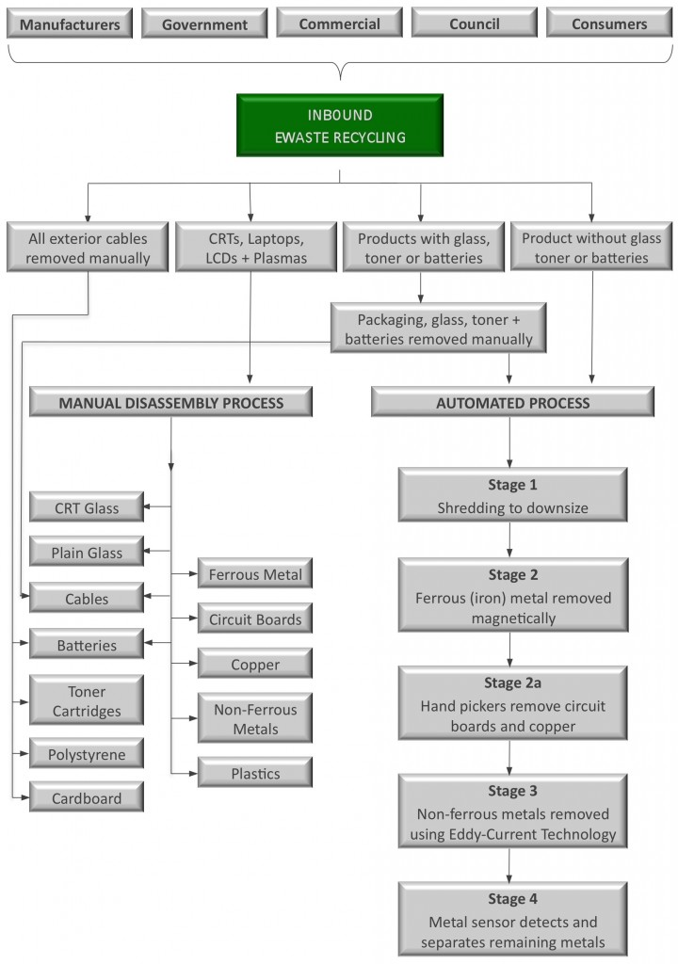

**Cathode Ray Tubes – recycling CRT Monitors and Televisions.**

Recycling Cathode Ray Tubes, most commonly found in computer monitors and old televisions, is more complicated than recycling most electronic waste. This is because toxins found within CRT’s are among the most dangerous – CRT’s have lead in the glass which can seriously harm the environment and our health if leaked into soil and water systems.

* Separation of Monitor Body and Cathode Ray Tube – firstly the front of the monitor is removed so that the tube can be removed from within. The shell is then recycled along with regular ewaste.
* Size reduction process – The tubes and screens are shredded down into small pieces. Any glass dust created in this process is disposed of carefully, in an environmentally friendly way.
* Metal Removal – the broken bits of glass are then passed under magnets, where iron and steel is extracted from the glass material. The remaining material is then passed through Eddy Currents, which removes any aluminium and copper. These materials are then collected and reused as raw materials.
* Washing Line – The remaining glass is then cleared of oxides, phosphors and dust extracts, leaving just clean glass to be sorted.
* Glass Sorting Line – the final stage of CRT recycling sorts the leaded glass from the unleaded glass. These can then both be used in the creation of new screens, which is called closed loop recycling.

**COMPANIES HANDLING E-WASTE**

|  |  |  |
| --- | --- | --- |
| **COMPANY LOGO** | **COMPANY NAME** | **DESCRIPTION** |
|  | Adatte E Waste Management | A comprehensive e-Waste management organization that processes the entire hazardous printed circuit boards waste within and for India in an eco-friendly way |
|  | Attero | India's only end-to-end e-Waste recycler and metal extraction company that has also developed a disruptive technology that sets-up low cost, low capacity eco friendly recycling recycling plants for processing e-Waste |
|  | BaoBab Clean Tech | An e-Waste management venture providing solutions that maximize the value recovery for clients while providing environmentally responsible processes along with mangaing liability of the IT assets |
|  | Cerebra integrated technologies | Boasting of having one of the largest e-Waste facilities in India, the company offers repair, refurbishment and reuse of all electronic and electrical equipments |
|  | E Incarnation Recycling | Uses the best available environmentally sound technologies to mitigate the hazardous effects of improper treatment and disposal of E-waste, ensuring protection and preservation of the environment |
|  | Ecobirdd Recycling | Promotes e-waste awareness among businesses and general public and conserves the nature with its tech-based e-waste recycling solutions |
|  | EcoReco | Best-in-class scientific e-waste recycling facility in India that uses latest technologies from Europe, U.S., and Japan |
|  | ECS Environment | Delivers intelligent, improved and personalized solutions which cover the entire life cycle of IT products through its IT solution centers, remote managed sevices and e-waste management |
|  | Exigo Recycling | Building a continuum between collection and disposal process of the e-Waste through its unique EPR (Green Underwriting Services) and rigorous data security solutions (mobile/portable shredding, witness and prototype destruction services) |
|  | ExtraCarbon | Collects recyclable waste from homes & other commercial places andsends the material to respective recyclers |
|  | Green Recycling | Provides eco-friendly, innovative and economic electronic waste recycling solutions to the organizations across |
|  | GreenWaves | An e-Waste company that collects e-Waste items to reduce, reuse, recycle and recover them into products through continuous implementation and innovations in recycling technology |
|  | GS International | Provides quality e-Waste recycling programs to assist organizations in treating their e-waste in a safe manner |
|  | High Tech Recycling | Conducts a responsible in-house de-manufacturing service for non-reusable and/or non-resalable products in order to achieve the environmental obligations of zero landfill |
|  | NAMO E waste management | A pioneer in asset management and electronics recycling services to efficiently manage, dispose and recycle discarded electronic items |
|  | Pruthvi E Recycle | Engages in recycling the Electronic-Waste CPU, Monitor, Keyboard,Mouse, UPS, and Power Chords in an organized manner using necessary technology & methodology |
|  | Re teck | A reverse supply chain management company offering post-consumer take-back and recycling, closed loop of components and 3R solutions to major electronics & technology brands, thereby decreasing e-Waste for used and outdated devices |
|  | ViroGreen | Offering a suite of services in e-waste management, including waste management in the field of electronic and electrical goods, plastics plus data security services |
|  | Z Enviro industries | Being one of the oldest certified collector and dismantler, it places lot of emphasis on protecting the environment and encourages people to dispose their e-Waste through proper channel |

**CONCLUSION**

The hazardous nature of e-waste is one of the rapidly growing environmental problems of the world. The ever-increasing amount of e-waste associated with the lack of awareness and appropriate skill is deepening the problem. A large number of workers are involved in crude dismantling of these electronic items for their livelihood and their health is at risk; therefore, there is an urgent need to plan a preventive strategy in relation to health hazards of e-waste handling among these workers in India. Required information should be provided to these workers regarding safe handling of e-waste and personal protection. For e-waste management many technical solutions are available, but to be adopted in the management system, prerequisite conditions such as legislation, collection system, logistics, and manpower should be prepared. This may require operational research and evaluation studies.

**REFERENCES**

* <https://www.thebalancesmb.com/introduction-to-electronics-e-waste-recycling-4049386>
* <https://www.ewaste.com.au/ewaste-articles/how-is-electronic-waste-recycled/>
* <https://enterprise-services.siliconindiamagazine.com/ranking/20-most-promising-ewaste-management-companies-2018-rid-398.html>
* <https://en.wikipedia.org/wiki/Electronic_waste#Other_informal_e-waste_recycling_sites>
* <https://www.ncbi.nlm.nih.gov/pmc/articles/PMC2963874/>
* https://www.ncbi.nlm.nih.gov/pmc/articles/PMC2963874/